**Building Partnerships**

* PTO/Open House-September 1, 2022 5:45 p.m.
* Home/School Partnerships by grade level
* Title I Document Input/Review August/September
* 2022-23 Westwood Family Nights- Literacy Night-Nov. 3, Math Night-Jan. 19, Science Night-April 20
* Career Day Oct. 31
* Kid City Contact Malisa Pedro 706-876-4000
* WW Office: Contact Hortensia Hurtado or Ashley Hernandez at 706-876-4425
* WW PTO: Contact Lindsay Lofty at 706-876-4425
* Parent University: Contact Jackie Taylor at 706-876-4506
* Little Cats: (Pre K): Contact Saira Laruy at 706-281-5878
* Caring is Sharing (Christmas): Contact Jackie Taylor at 706-876-4506

**Communication about Student Learning**

Westwood School is committed to maintaining two-way communication with families through the school year about student learning progress and academic achievement. Some of the ways you can expect us to reach you are:

* Student communication folders
* Reports of progress and report cards
* Infinite Campus Parent Portal
* Telephone calls/Remind Text Service/DPS App
* Flyers/Newsletters
* Parent-teacher conferences
* School website/Social media
* Workshops and parenting classes
* Notes sent home and email
* Canvas

**Jointly Developed**

This School-Parent Compact for Achievement was jointly developed by the parents, students, and staff of Westwood School. Teachers suggested ways that parents can help students at home, and parents added ideas about their needs in this process. Students helped us with suggestions about ways that they learn best. Meetings are held each year to review the compact and to make changes based on what our students need.

**We welcome comments from parents, students, and staff at any time!**

**706-876-4425**

**What is a School-Parent Compact?**

A School-Parent Compact for Achievement is an agreement that parents, students, and teachers develop together which explains how all will work together to make sure all of our students master grade-level standards.

Effective compacts:

* Link to goals of the school improvement plan
* Focus on student learning
* Describe how teachers will help students develop those skills using high-quality instruction
* Share strategies parents can use at home
* Explain how teachers and parents will communicate about student progress
* Describe opportunities for parents to volunteer, observe, and participate in the classroom



**SCHOOL-PARENT COMPACT**

**FOR ACHIEVEMENT**

**School Year 2022 – 2023**



**Westwood Elementary School**

**PK-5**

**Title I School**

**Scott Ehlers, Principal**

**708 Trammell Street Dalton, GA 30720**

**Tel (706) 876-4425**

**Fax (706) 278-1379**

**westwood.daltonpublicschools.com**

**At Home**

How to support your children:

* Maintain a home environment where learning is a priority
* Ask your child to talk about what they are learning and reading
* Monitor television and video game play
* Be consistent with expectations, such as a routine bedtime
* Attend Parent-Teacher conferences
* Check homework and planners
* Attend school events
* Listen to your child read every night
* Volunteer at Westwood
* Promote independence, respect, and responsibility

**Students**

Westwood Student Leaders gave us feedback about our school. Here are their suggestions to help students connect learning from school to home:

* Bring work home to share with parents and ask for their feedback
* Involve their families in all school events
* Apply everything they are learning to real life at home and at school
* Be respectful, responsible, and follow the Wildcat Ways

School administrator signature: Date: School teacher signature: Date: Parent/Guardian signature: Date: Student signature: Date:

**District Goals**

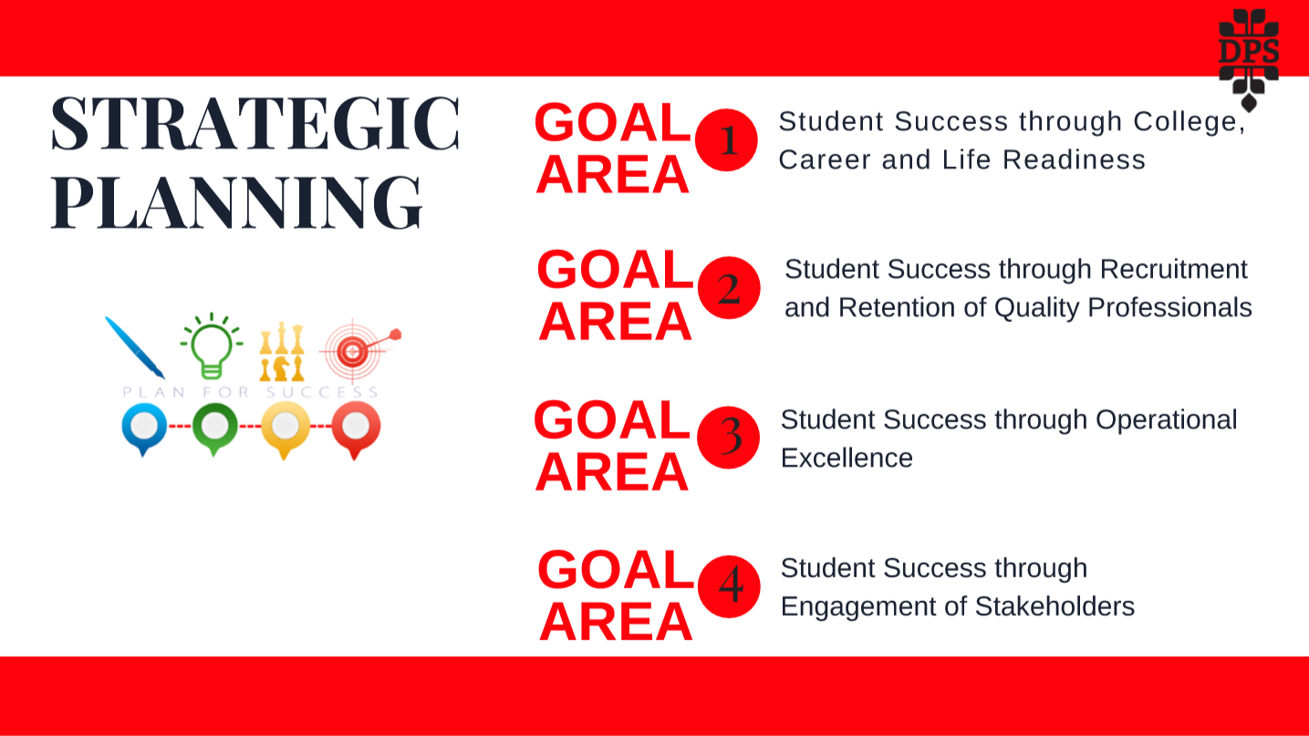

-Increase all District EOC and EOG scores by 6%.

**Westwood School Goals**

- *75% of students in third grade, 58% of students in fourth grade, and 79% of students in fifth grade will be reading at or above the Lexile mid-point.*

*-46% of students in third grade, 49% of students in fourth grade, and 46% of students in fifth grade will score at proficient or above on the ELA section of the Georgia Milestone EOG.*

*-52% of students in third grade, 46% of students in fourth grade, and 41% of students in fifth grade will score at proficient or above on the Math section of the Georgia Milestone EOG.*

*-42% of students in fifth grade will score at proficient or above on the Science section of the Georgia Milestone EOG.*

cid:image002.jpg@01D2C7EE.52E15A50

**Working Together, The Westwood Way**

**In the Classroom**

Westwood School staff will work with students and families to support student academic achievement in all content areas. Some of the ways we will do this include:

* Designing engaging work for students that results in profound learning
* Offering parent resources electronically and in print, with ideas and suggestions for supporting the academic learning process
* Offering family nights focusing on academic content (Literacy, Math, and Science)
* Offering opportunities for parents to become more involved in volunteer activities at Westwood